Staves with a Twist
Introduction
The basic principle is to drill through a stave blank at an angle and not through the center as is typical. This sounds straight forward enough but will test your skills. As with all woodworking, stock preparation is crucial. It is particularly important in this case since dimensional consistency will aid in accurate drilling. Staves made from stock of the same dimensions will gave a solid blank.
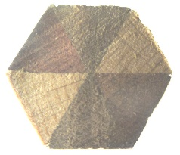 | Mahogany, walnut, and maple
By way of experiment, having made, drilled, and turned several such blanks there is more than one possible approach, as you might expect. The first approach was to cut parallel miters at the drilling angle with the aim of drilling at 90 deg to the entry face and exit at 90 deg to the exit face. This works in theory but requires very accurate setup and drilling, which is not easy to achieve consistently. So that approach was abandoned in favor of drilling at a set angle into the top face and accepting the exit point, having setup as accurately as possible. Minor variations this way doesn’t seriously affect the outcome. What follows is based upon the latter approach. Your results may vary .
Varying the entry and exit points will give different results. The number of staves does not matter but an even number will be easier to use (see below). In some cases, it may be best to use a round blank (see below) or if that is a preferred approach. With care, either should yield a positive result. The choice is left to the reader.
The composition of the stave blank is simply up to your imagination, eg. contrasting woods, veneers, plastic, etc. However, to ensure a good result, there should be no hole down the center, or this might show up when turning. This will dictate how the staves are made. This is left up to the reader.

Method
- Prepare stock to produce a staved blank of between 1” and 1 ½” in diameter – this gives some margin for drilling error and, also will be dependent upon the final use, ie. the size of the hole you plan to drill
- The blank length should be such that there is sufficient room at the ends to square to the tube and cover the bushings so that there is no gap when turned – experience will tell
- If necessary, sand the cut surfaces to ensure a sound glue-up with no gaps
- Make sure that there will be no hole down the center, or it may show up while turning
- Make sure that the glue-up is accurate – consistent face to face dimensions are important because faces may be used as a reference when drilling
- With blanks of multiple faces the blank is approximately round, and it might be best to turn it round on the lathe before drilling
- If making all blanks round regardless of the number of sides is preferred, then proceed in that manner
- Blanks must be well secured during drilling to avoid out of round or wandering holes - holding the blank firmly in place will be aided by having an even number of staves giving opposing flat surfaces
- Choose a drilling angle such that the exit point is in the opposite end of the blank and the drill bit does not go out through the side - from experience somewhere between 10 and 15 deg seems about right based up where you want the drill bit to exit, the length of the blank and the size of the hole – only experience will tell you
- Since you will be drilling through perhaps different woods and different grains and turning a segmented blank, it is recommended to let the glue-up sit overnight
- Decide upon the drill bit entry point and drilling angle – this determines the exit point

 | 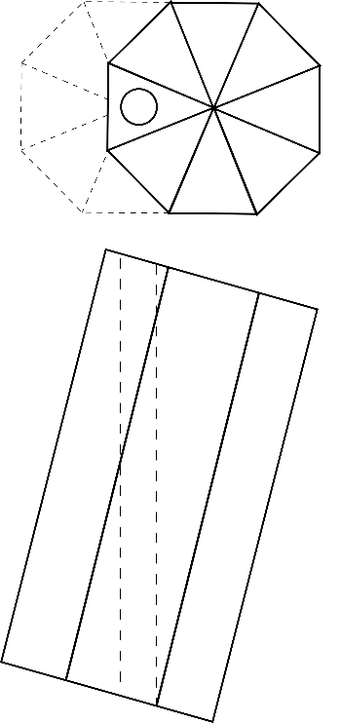 |  | To drill vertically there are 2 options:  - hold the blank at the drilling angle in an angle vice (see below) – easiest and likely most accurate  - hold the blank at the drilling angle in a regular vice  Accuracy here can save a lot of grief later  When drilling, place a sacrificial piece under the blank to prevent blowout and protect the drill bit | 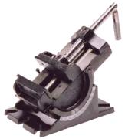  Angle vice
To aim for an exit point the same distance from the centre as the entry point calculate the drilling angle as:
Inversetangent (2 x distance from the centre divided by blank length)
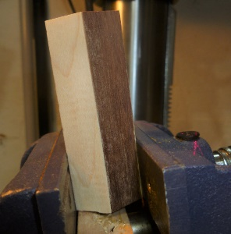  Sacrificial piece |  | 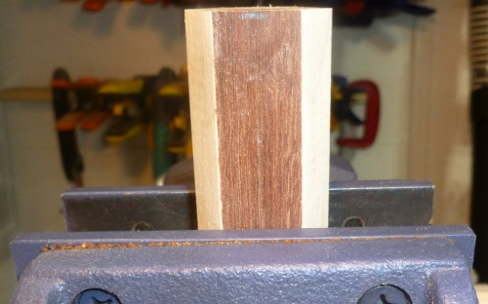  90 deg to drill bit

- For the drill bit to exit as planned take care with the setup – time taken here will bring its rewards – check setup at least twice!
- It is strongly recommended to use epoxy or polyurethane glue (watch out for the expansion) for securing the tube in the blank – near the ends the grain can be going in all directions and possibly some very small pieces will readily take their leave when turning

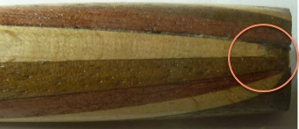 | This what you get if you aren’t careful
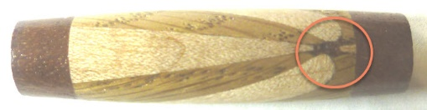 | Or this where the grain will be wild

- If using a pen mill to trim to the tube take great care or the blank may chip and be ruined as it might be approaching the blank at an angle – this can be improved by mitering the ends of the blank at the drilling angle just leaving a small amount to be removed by the pen mill (accuracy is not important)
- If end pieces are planned, after turning down to near final size cut down to the tube to create space for end pieces – remove the blank from the lathe, glue and trim the end pieces and return to the lathe - this has the advantage that the end pieces can be squared to the tube even if the drilling was not perfect
- If end pieces are not planned, then there is more room for error since the tube is squared to the end faces as they are trimmed to the tube – ensure that you leave enough space on the ends for the trimmed blank to sit square to and cover the bushings – experience will tell how much to leave
- It pays to take great care when the ends are approaching the thickness of the bushings – use thin CA to stabilize – experience will tell you how often and when to start – better earlier than later or you will likely have small pieces which take their leave
- Well done, if you have made it this far without incident – finish the blank to your choice

Examples
Examples that stayed in one piece but weren’t made into pens:
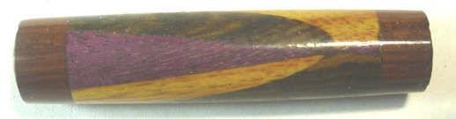 | Purpleheart, canary wood and zebra wood (don’t know what the ends are made from, but it is hard and heavy)
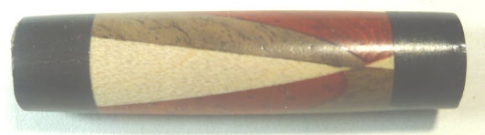 | Padauk, walnut and maple with ebony ends

Examples that made it all the way: 
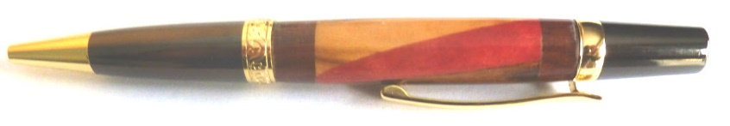 | Sierra – zebra wood, pink ivory, and canary wood (ends ?)
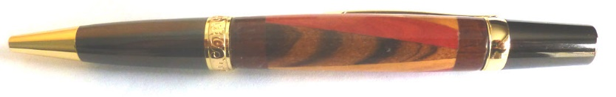 | Sierra – zebra wood, pink ivory, and canary wood (ends ?)
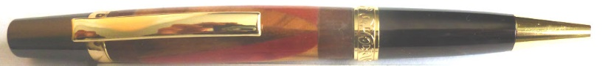 | Sierra – zebra wood, pink ivory, and canary wood (ends ?)

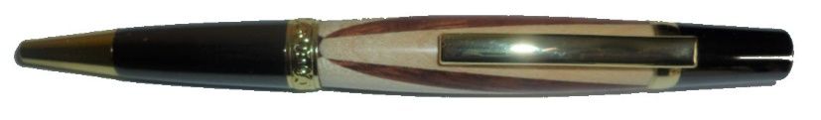 | Sierra – mahogany and maple
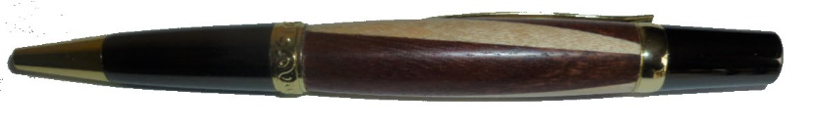 | Sierra – mahogany and maple
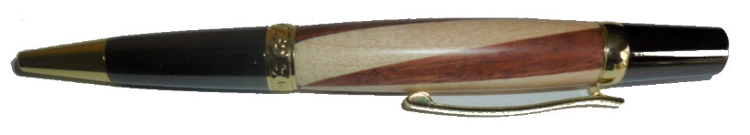 | Sierra – mahogany and maple

Experimenting and coming up with something new and different is what gets us up in a morning! So go and enjoy your turning. We all want a good result, but what we learn during the journey about woodworking and ourselves is often just as important. I learned a lot during this exercise and not just about making stave pens with a twist .

