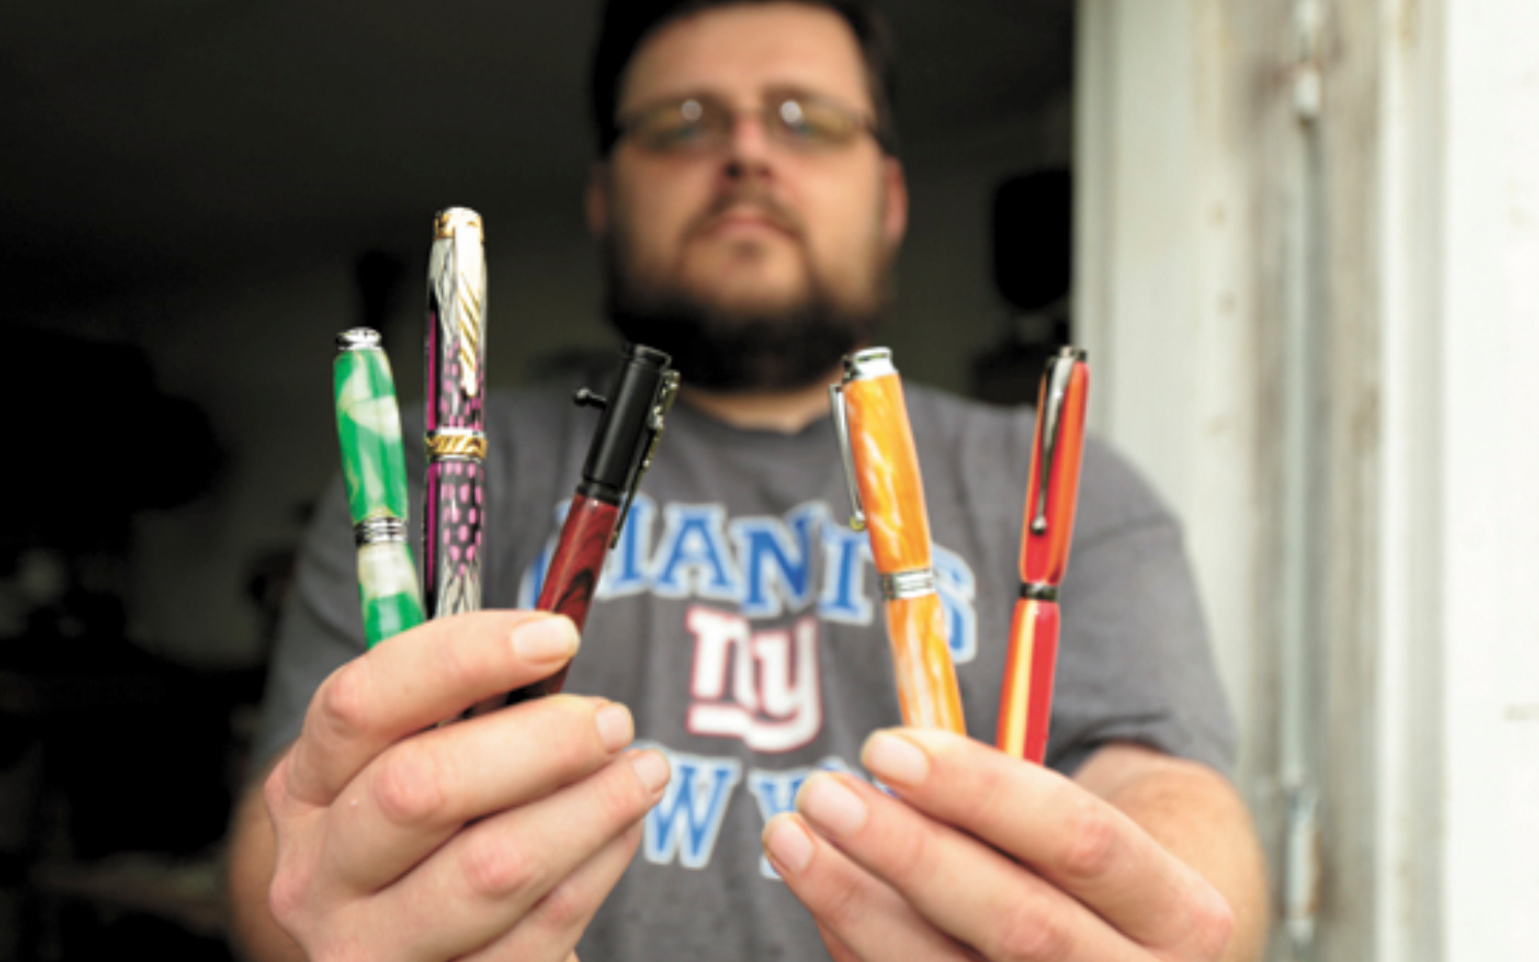
I GOT 99 PROBLEMS
BUT A BIC AINT ONE

