Thank you for contacting Darex about your Drill Doctor 750X. Let’s do a quick run-through.

- Set your material take-off knob to maximum material take-off if you have some damage to repair. If no obvious damage, roll it forward about 3 lines. (Short or long lines don’t matter, just count three.)
- Align your drill bit correctly. To start, I would highly recommend aligning your chuck directly in the slot below the 118° mark. If you are sharpening 135° drill bits, I find aligning 1-notch towards the negative gives a nicer split.
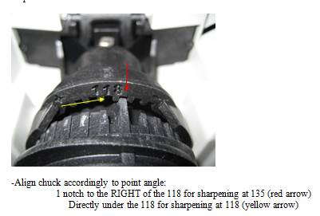

- Push paddle to open alignment fingers. Make sure drill bit is pushed up to the drill stop. Let go of those metal fingers now & make sure bit is held in the narrowest part of the drill. Make sure they are not falling into the cut-away portion of the split. They have to be in the flutes. Now tighten your chuck.

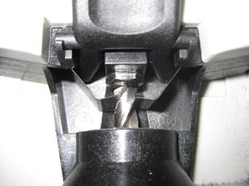

- If you are sharpening 118° drill bits, make sure you have your sharpener set at 118°.
If you are sharpening 135° drill bits, make sure you have it set at 135°.

- Now, let’s sharpen. Line up one of the white lines with the metal cam guide & do clockwise rotations, until there is no more grinding noise. This will take a while! Make sure your chuck is always touching that metal cam pin as you do those rotations.

- Once you have reached spark-out (no more grinding noise at all) take a look at your drill bit. The chisel angle should be at 1 o’clock or 1:30.

*Look at the bit: Hold the bit up and look at it with the cutting edges in line with the
horizon (or parallel with the 9:00 and 3:00 position imagining a clock's face).
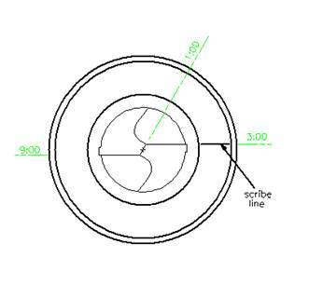
2:00 is too far advanced, and if the chisel gets too close to 12:00, the relief will be negative.

Too much relief will cause an oversized hole diameter and rapid bit wear.
Too little relief will limit feed rates, slowing down the drilling operation or in extreme cases cause the drill not to perform at all.

If chisel angle looks to be about 2 o'clock, align bit 1-2 ticks in the minus direction.

If chisel angle is up to about 2:30, align 2-3 ticks minus.

If chisel angle is about 12:45, it's at the low end of chisel & relief, align 1 tick to positive.

FYI: The twist rate of the drill bit plays a large factor in how you align it.
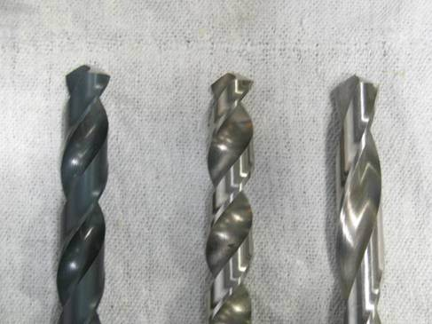
The helix angle of drill bits is not a standard. Helix angles vary from slow (not many turns per inch) to fast (lots of helical spirals going up the bit). Bits sharpened at the same setting will have remarkably different chisel and relief angles.

Now, let’s look at some examples:

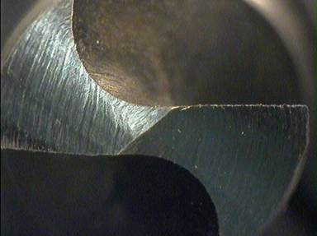
This looks like too much relief and too much of a chisel angle. We need less of both, so we turn our alignment to "-" to get less. (We turn to the right or clockwise.)

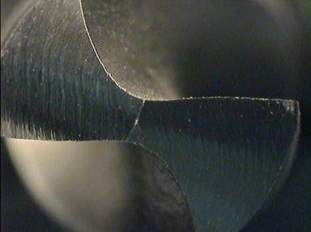

This looks like too little chisel and relief, so we want more of both, so we turn our
alignment system towards the "+" to get more. (We turn to the left or counter clockwise).

These slow helix drills are becoming more common, so adjusting one or two ticks to the right during alignment is not uncommon. Actually, this is a pretty good bit and will drill a very good (accurate) hole. However, the "apparent" relief looks to be about 0 degrees (even though there is actually plenty of lip relief).

- If your chisel angle is in the correct location, and you have completed the grind cycle, now is the time to move to split. This step in necessary for 135° drill bits (as they have wide chisel tips) but optional for 118° drill bits. The split acts to narrow a wide chisel tip, and create a secondary cutting edge.

That is probably too much information, but I hope it will assist you in your efforts.

