TonyL’s 4 Stage DIY Buffing System and Parts List

I use this on my Jet 1221 to finish all non-bare wood finished, plastics, acrylics, CA, etc. It can also be used on bare wood, but I prefer to have at least a few coats of thin (or medium) CA
You can adjust the length of the threaded rod and the number of and distant between sets of buffs (also number paired buffs) to accommodate the Jet 1015.
15 or so inch Length of ½ All Thread Rod (metal threaded rod). It does not have to be stainless steel. The same goes for all of the hardware – you can use SS if you want. Also remember that the threaded rod can be cut down to size. I found 18 inches to be too big and 12 inches slightly small. I would buy the 18 inch length and cut to size AFTER you have installed and spaced-out your buffs.
It’s up to you of course, but I wear a dust mask and glasses when I use this system. I also keep my dust collector running about 9 inches from my lathe to accommodate the diameter of the buffing wheels.

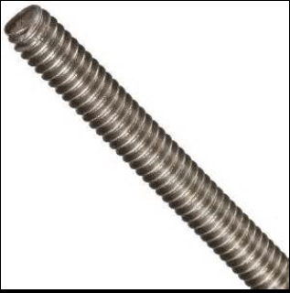

8 – ½ inch hex nuts
http://www.homedepot.com/p/Everbilt-1-2-in-Zinc-Plated-Coarse-Threaded-Hex-Nut-804716/204647892
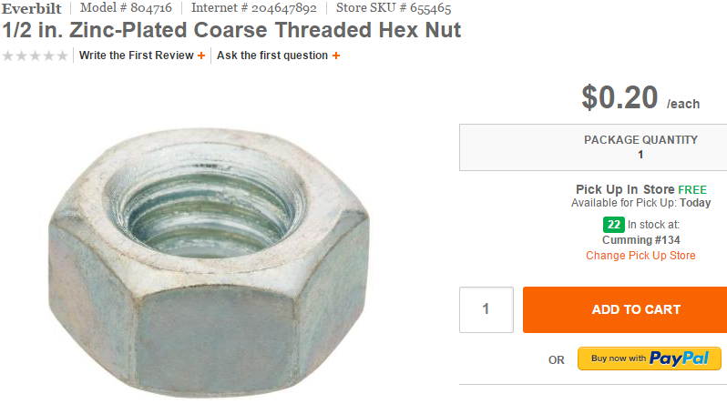
8 – ½ inch fender washer (large washers). They do not have to be stainless steel.
http://www.homedepot.com/p/Everbilt-1-2-in-x-2-in-Metallic-Stainless-Steel-Fender-Washer-2-per-Pack-800541/204284504

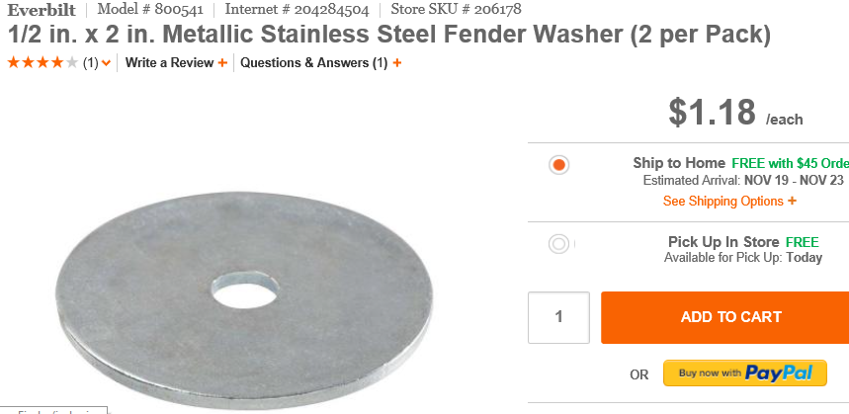

8 – ½ inch lock washer. I prefer using lock washers over nylon locking nuts or Loc- Tite. I have tried all three ways, and I have this to be the easiest and most flexible in terms of installation and removal. Whatever you decide, you must use a means to lock the buffs in place. Otherwise, the rotation of the lathe will cause them to loosen.

http://www.homedepot.com/p/Crown-Bolt-1-2-in-Zinc-Plated-Split-Lock-Washer-20266/205026606
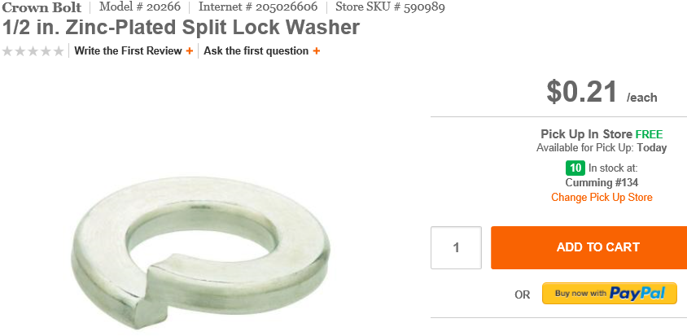

You will install the following combination of hardware on each side of your sets of buffs:
- The fender washer is position right against the buff.
- Then the lock washer follows and is position against the fender.
- Lastly, the nut is tightened against the lock washer.
1 - Wooden or metal 2MT drive center to fit into the headstock and accept the ½ inch diameter threaded rod
1 – 2MT live center with a cup or the spur drilled-off to accept the tailstock end of the a ½ inch All Thread rod.

12 (3 per stage) – 8 inch Cotton/Linen Buffs. I like to place 3 buffs together for each stage. It provides a nice, large buffing surface. You can certainly use 2 per stage or each 1. I would be concerned about using just one..but I am sure it can be done. You can also use smaller and larger diameter buffs.
I space each set of 3 buffs about 3 ½ inches apart on center. You don’t want the too close or the stages that are not using are likely to interfere with your hands and wrists.
http://www.caswellplating.com/canton-flannel-wheel-8-x-1-2.html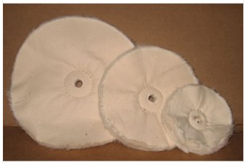
1 -Tripoli Polish NOT THE WAX (to charge the first stage)
http://www.woodcraft.com/Product/141073/Beall-Tripoli-Bar-6-x-2-x-1.aspx
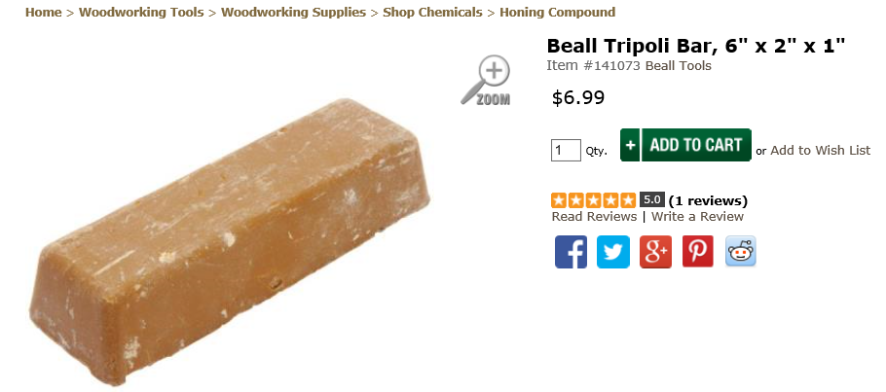

1 - White Diamond (to charge the second stage). This polishes and removes the residual Tripoli)
http://www.woodcraft.com/product/141072/beall-white-diamond-bar-6-x-2-x-1.aspx
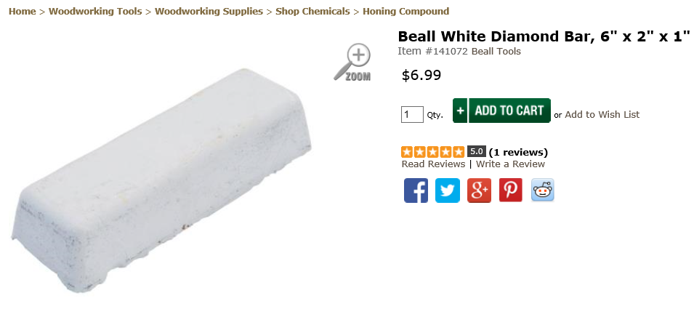

Most folks including Beall stop here, and that is fine. I proceed with two more grades to remove even the finest scratches.
1- P-22 (to charge the third stage). Even though the seller calls this “ultra-fine”, it is not as fine as the compound below. The seller admits this is confusing to many.
http://www.caswellplating.com/buffing-polishing/specialty-buffing-compounds/plastic-glo-ultra-fine-dry-grade-p-22.html
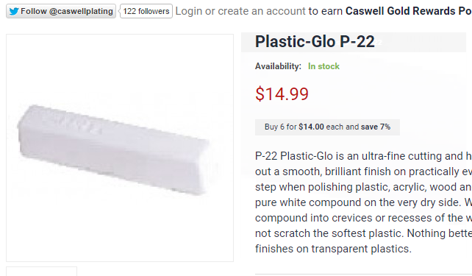

1 - Final Stage Buffing Compound (P-112)
http://www.caswellplating.com/buffing-polishing/specialty-buffing-compounds/plastic-buffing-compound-fine-p-112.html
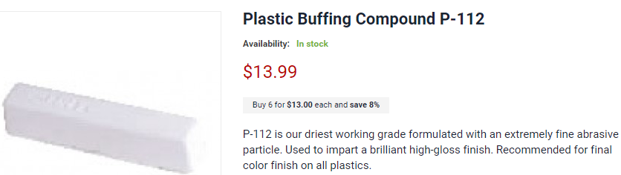

Make your own 2MT to fit into your headstock with a 5/8ths to ¾ inch DEEP hole in it to accept the threaded rod (use Epoxy to secure threaded rod into the 2MT). I also had made a 2MT with a ½ inch female thread tapped into it. I purchased it from

I dry sand:
Starting 220 to 400 depending on the tool-finish and material,
320
400
600
800
1,000
1,500
2,000

I found the 800 through 2,000 grits in Home Depot. 3M makes them (so does Norton, etc.), they are dark grey/black and sold as wet/dry sandpaper. I only use it dry. I used to stop and 600 Abranet, then I experimented with higher grits. I found this to produce better results and reduce buffing time.
http://www.homedepot.com/p/3M-3-66-in-x-9-in-1000-Grit-Sandpaper-10-Sheets-Pack-5923-18-CC/205421841?MERCH=REC-_-SearchPLPHorizontal1_rr-_-NA-_-205421841-_-N


I dry sand at no higher than 500 rpms, and I sand in reverse.
Then I move the material to the buffing station. MAKE SURE YOU CHANGE THE DIRECTION TO FORWARD WHEN BUFFING. I have buffed between 800 and 1,700 rpms. The faster the rpms, the more cutting you will do, but will also produce more heat. It took me a short while to get a feel for how fast, how long, and how pressure to apply when buffing for each material. You also want to ensure that you buffs the ends of your blanks. Most finished barrels are curved (convex); the buffing wheels are obviously round. It’s not always apparent that the buffing wheels are making contact with the sections of the barrel that curve away from the buffing wheels. I examine my work often under a 10X magnification light to measure my progress and finish.
Finally (and this is optional), I apply very little plastic polish to remove any compound residue, and a dab of non-cleaner wax for protection.
Also keep in mind that this can be scaled-up or down to suit the morse tapers of your lathe and length of your lathe bed.

After every 10 barrels or so, I use this to “fluff-out” my buffs:
http://www.caswellplating.com/buffing-polishing/wheel-rake/wheel-rake-complete-unit-handle-teeth.html
I find gently (but firmly holding) the rake against the wheel at no more than 300 to 400 rpms in reverse works best. Needless to say, if you don’t have reverse that works too – just make sure you firmly grip the rake with both hands (one of each side of the wooded handle)
Here is what mine looks like when it is spinning.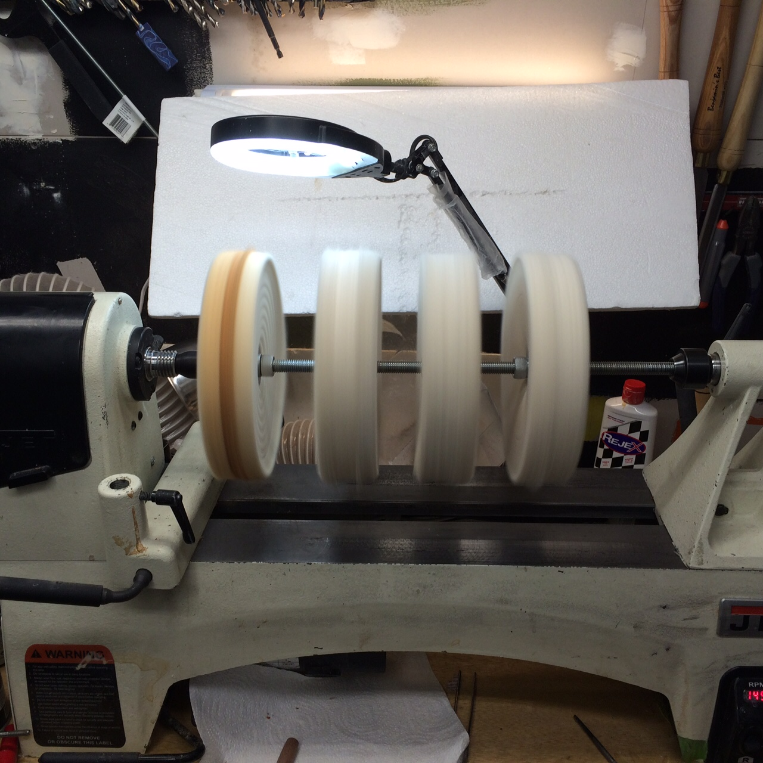

Remember, this just happens to be the way that I polish pens. You may find another approach better or that you get better results with wet-sanding.

Happy Turning!

TonyL

